**ANSWER 1:**

**CODE:**

using System;

namespace Facebook

{

class Tyre

{

public static void TyreType()

{

Console.WriteLine("Tyre is Tubeless");

}

}

class Scooter : Tyre

{

public void show()

{

Console.WriteLine("Scooter");

Tyre.TyreType();

}

}

class Car : Tyre

{

public void show()

{

Console.WriteLine("Car");

Tyre.TyreType();

}

}

class Program

{

static void Main(string[] args)

{

Scooter s1 = new Scooter();

s1.show();

Car c1 = new Car();

c1.show();

Console.ReadKey();

}

}

}

**OUTPUT:**

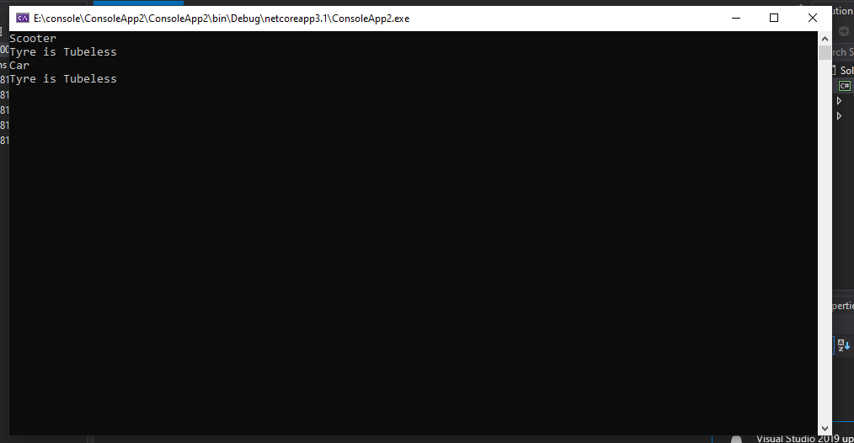

**ANSWER 2:**

**CODE CLASS:**

using System;

using System.Collections.Generic;

using System.Linq;

using System.Text;

using System.Threading.Tasks;

using System.Windows.Forms;

namespace WindowsFormsApp4

{

class PRODUCT

{

public PRODUCT()

{ }

public PRODUCT(int A)

{

MessageBox.Show("Constructor 1---Hello this is parent class and value of A = " + A);

}

public PRODUCT(int A, int B)

{

MessageBox.Show("Constructor 2---Hello this is parent class and value of A and B = " + (A, B));

}

public PRODUCT(int A, int B, int C)

{

MessageBox.Show("Constructor 3---Hello this is parent class and value of A,B and C = " + (A, B, C));

}

}

class food : PRODUCT

{

public food(int X) : base(X)

{

MessageBox.Show("I am child class Of Product and My constuctor name is food and value of X is: " + X);

}

}

class cloths : PRODUCT

{

public cloths(int X, int Y) : base(X, Y)

{

MessageBox.Show("I am child class Of Product and My constuctor name is cloths and value of X and Y is: " + (X, Y));

}

}

class hardware : PRODUCT

{

public hardware(int X, int Y, int Z) : base(X, Y, Z)

{

MessageBox.Show("I am child class Of Product and My constuctor name is hardware and value of X,Y and Z is: " + (X, Y, Z));

}

}

}

**CODE PRODUCT:**

using System;

using System.Collections.Generic;

using System.ComponentModel;

using System.Data;

using System.Drawing;

using System.Linq;

using System.Text;

using System.Threading.Tasks;

using System.Windows.Forms;

namespace WindowsFormsApp4

{

public partial class Productt : Form

{

public Productt()

{

InitializeComponent();

}

private void button3_Click(object sender, EventArgs e)

{

Hardware h1 = new Hardware();

h1.Show();

this.Hide();

}

private void button2_Click(object sender, EventArgs e)

{

Cloths c1 = new Cloths();

c1.Show();

this.Hide();

}

private void button1_Click(object sender, EventArgs e)

{

Food f1 = new Food();

f1.Show();

this.Hide();

}

}

}

**OUTPUT:**

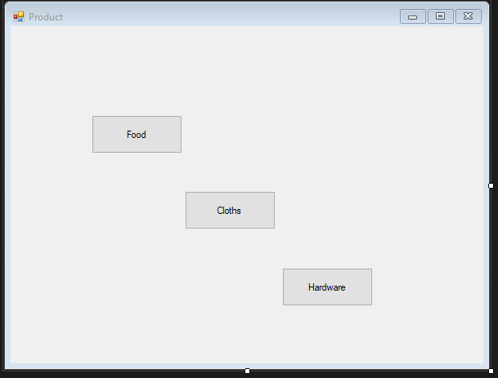

**CODE FOOD:**

using System;

using System.Collections.Generic;

using System.ComponentModel;

using System.Data;

using System.Drawing;

using System.Linq;

using System.Text;

using System.Threading.Tasks;

using System.Windows.Forms;

namespace WindowsFormsApp4

{

public partial class Food : Form

{

public Food()

{

InitializeComponent();

}

private void button1_Click(object sender, EventArgs e)

{

food f1 = new food(int.Parse(textBox1.Text));

}

}

}

**OUTPUT:**

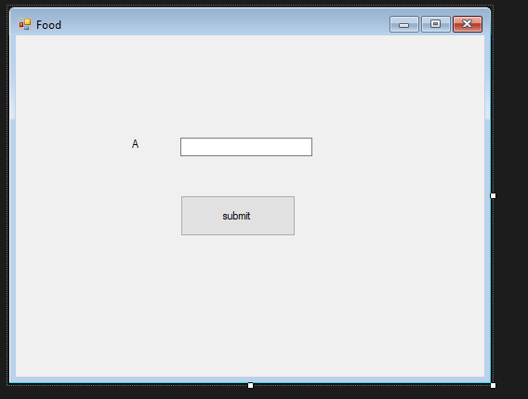

**CODE CLOTHS:**

using System;

using System.Collections.Generic;

using System.ComponentModel;

using System.Data;

using System.Drawing;

using System.Linq;

using System.Text;

using System.Threading.Tasks;

using System.Windows.Forms;

namespace WindowsFormsApp4

{

public partial class Cloths : Form

{

public Cloths()

{

InitializeComponent();

}

private void button1_Click(object sender, EventArgs e)

{

cloths c1 = new cloths(int.Parse(textBox1.Text), int.Parse(textBox2.Text));

}

}

}

**OUTPUT:**

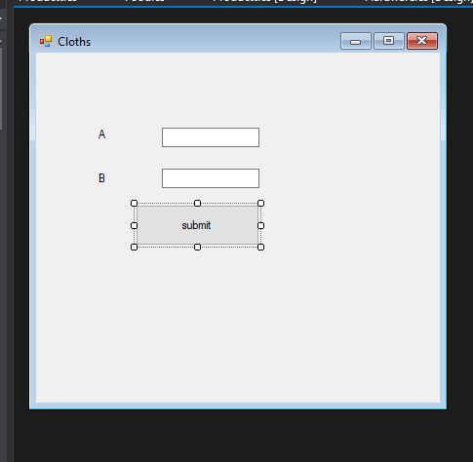

**CODE HARDWARE:**

using System;

using System.Collections.Generic;

using System.ComponentModel;

using System.Data;

using System.Drawing;

using System.Linq;

using System.Text;

using System.Threading.Tasks;

using System.Windows.Forms;

namespace WindowsFormsApp4

{

public partial class Hardware : Form

{

public Hardware()

{

InitializeComponent();

}

private void button1_Click(object sender, EventArgs e)

{

hardware h1 = new hardware(int.Parse(textBox1.Text), int.Parse(textBox2.Text),int.Parse(textBox3.Text));

}

}

}

**OUTPUT:**

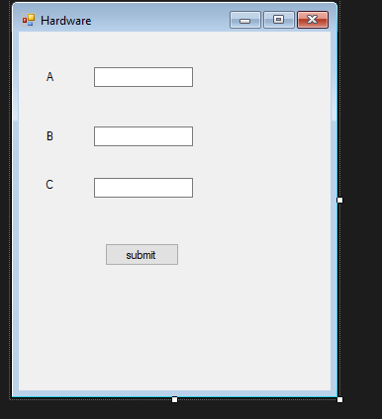

**RUN:**

